Phase 5 - Project Development Phase

The development is carried out in the ServiceNow instance using the System UI options. First the UI Policy is created, then the policy actions, and then the three Client Scripts.

High Impact Control - UI Policy

A new UI Policy named High Impact Control is created for the Incident table. The policy is made active and the condition is set as Impact is 1 - High.
Under the UI Policy Action, the Assignment Group field is made mandatory. The Reverse if false option is also enabled. Therefore, when the Impact is changed from High to another value, the mandatory condition is removed.

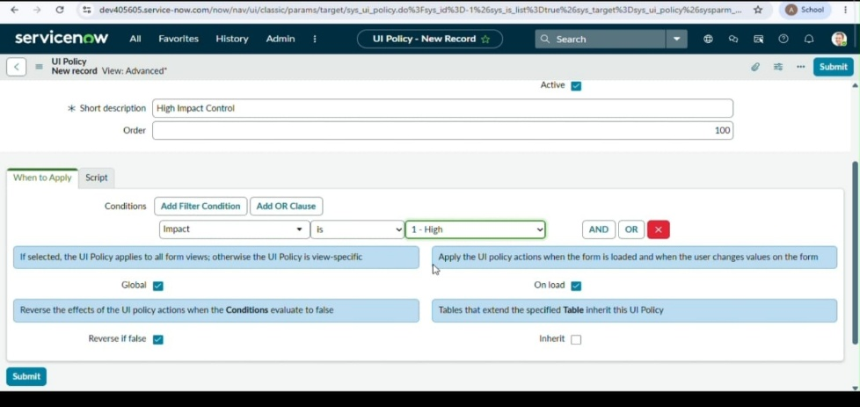

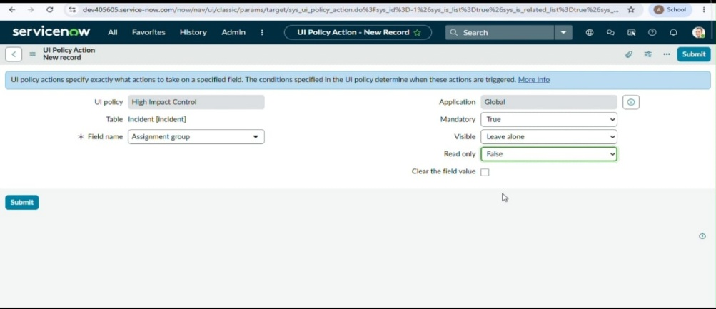
High Impact Control UI Policy Configuration

Configure Urgency Field

A UI Policy Action is created under the High Impact Control UI Policy. The field name is selected as Urgency and the Read-only option is enabled. When the Impact is High, the user can view the Urgency value but cannot change it manually.
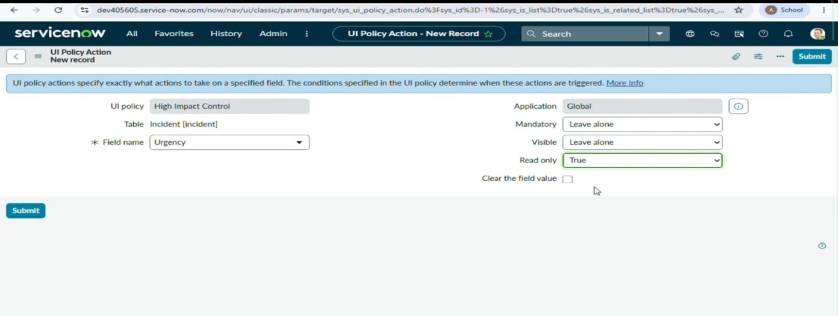
Urgency UI Policy Action

Client Script - Auto Set Urgency

A Client Script named Auto set urgency for high impact is created. The script type is onChange and the Impact field is selected. When the Impact is set to 1 - High, the script automatically changes the Urgency to 1 - High and displays an information message.

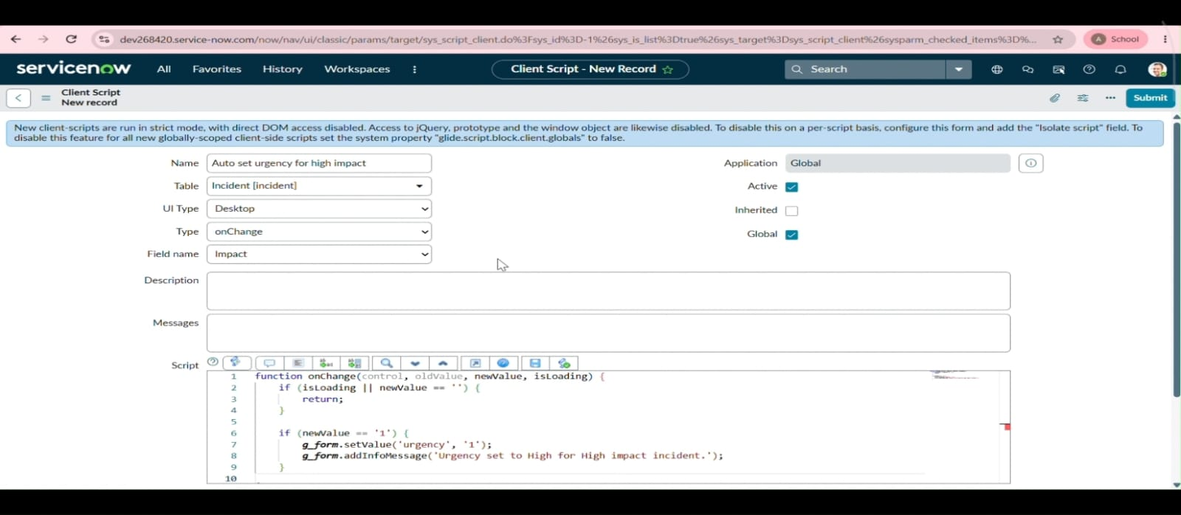
Auto Set Urgency Client Script

Client Script - Prevent Save if Assigned To is Missing

An onSubmit Client Script named Prevent save if Assigned To missing is created. The script checks whether the Impact is High and whether the Assigned To field is empty. If so, an error message is displayed and the record is not saved.

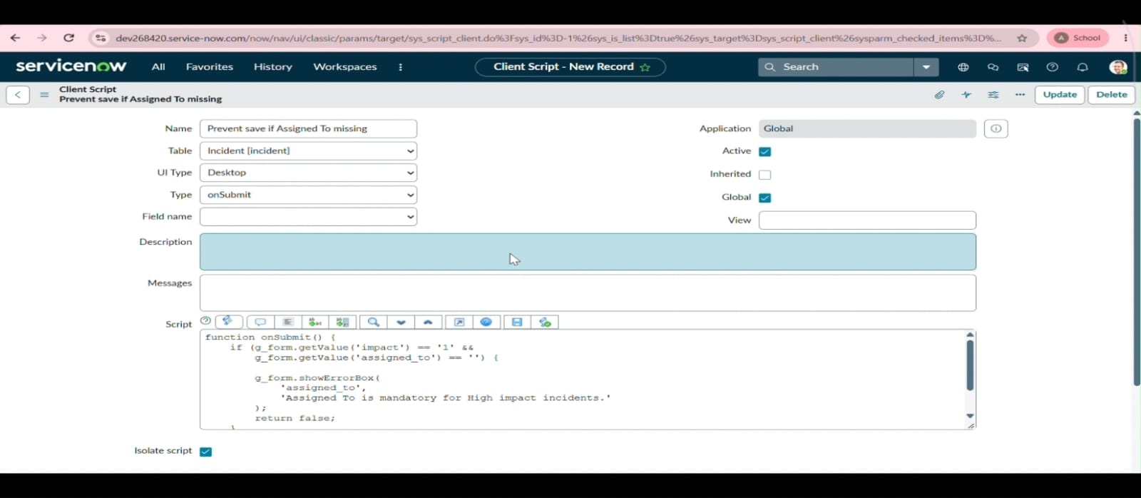
Prevent Save Client Script

Client Script - Prevent State Change Through List

An onCellEdit Client Script named Prevent state change via list edit is created for the State field. When the user tries to change the State from the Incident list, an alert message is displayed and the change is cancelled. The State can still be changed from the Incident form.

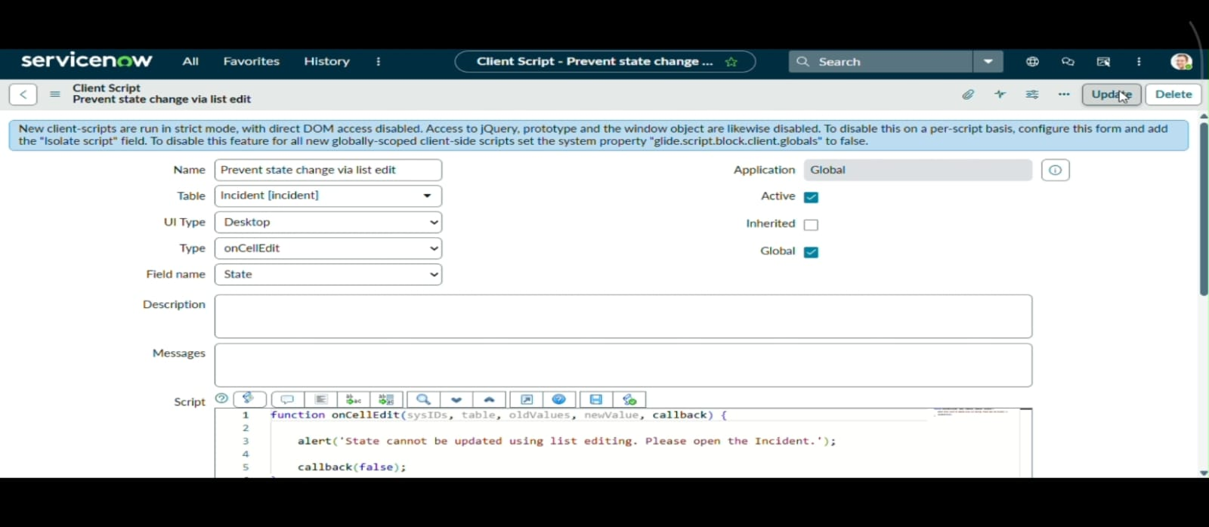
Prevent State Change Client Script

